E4: Circle Creation

Course: IGME 309 – Real Time Simulations for Games II

Golisano College of Computing and Information Sciences

School of Interactive Games and Media

Rochester Institute of Technology

Due: Check in MyCourses

Deliverable: Mesh.cpp file (single file, unzipped)

**Objective:**

The objective of this assignment is for students to develop a function that generates circles based on a set of triangles that share a common vertex. This exercise is designed to deepen students' understanding of computational geometry, trigonometry, and object manipulation in a graphical context. By the end of this assignment, students should be able to apply geometric principles to create dynamic shapes and understand the relationship between circles and triangles in 2D space. The assignment will also help students practice the following skills:

* Understanding the geometric properties of triangles and their circumcenters.
* Using trigonometric functions to calculate circle properties based on triangle parameters.
* Programming functions to dynamically generate and visualize geometric shapes.
* Developing a deeper understanding of how complex shapes can be broken down into simpler components for computation and graphical representation.

**Instructions:**

This exercise follows lecture D04

1. In the root of the repository look for the example execution under _Binary. It will look like this:

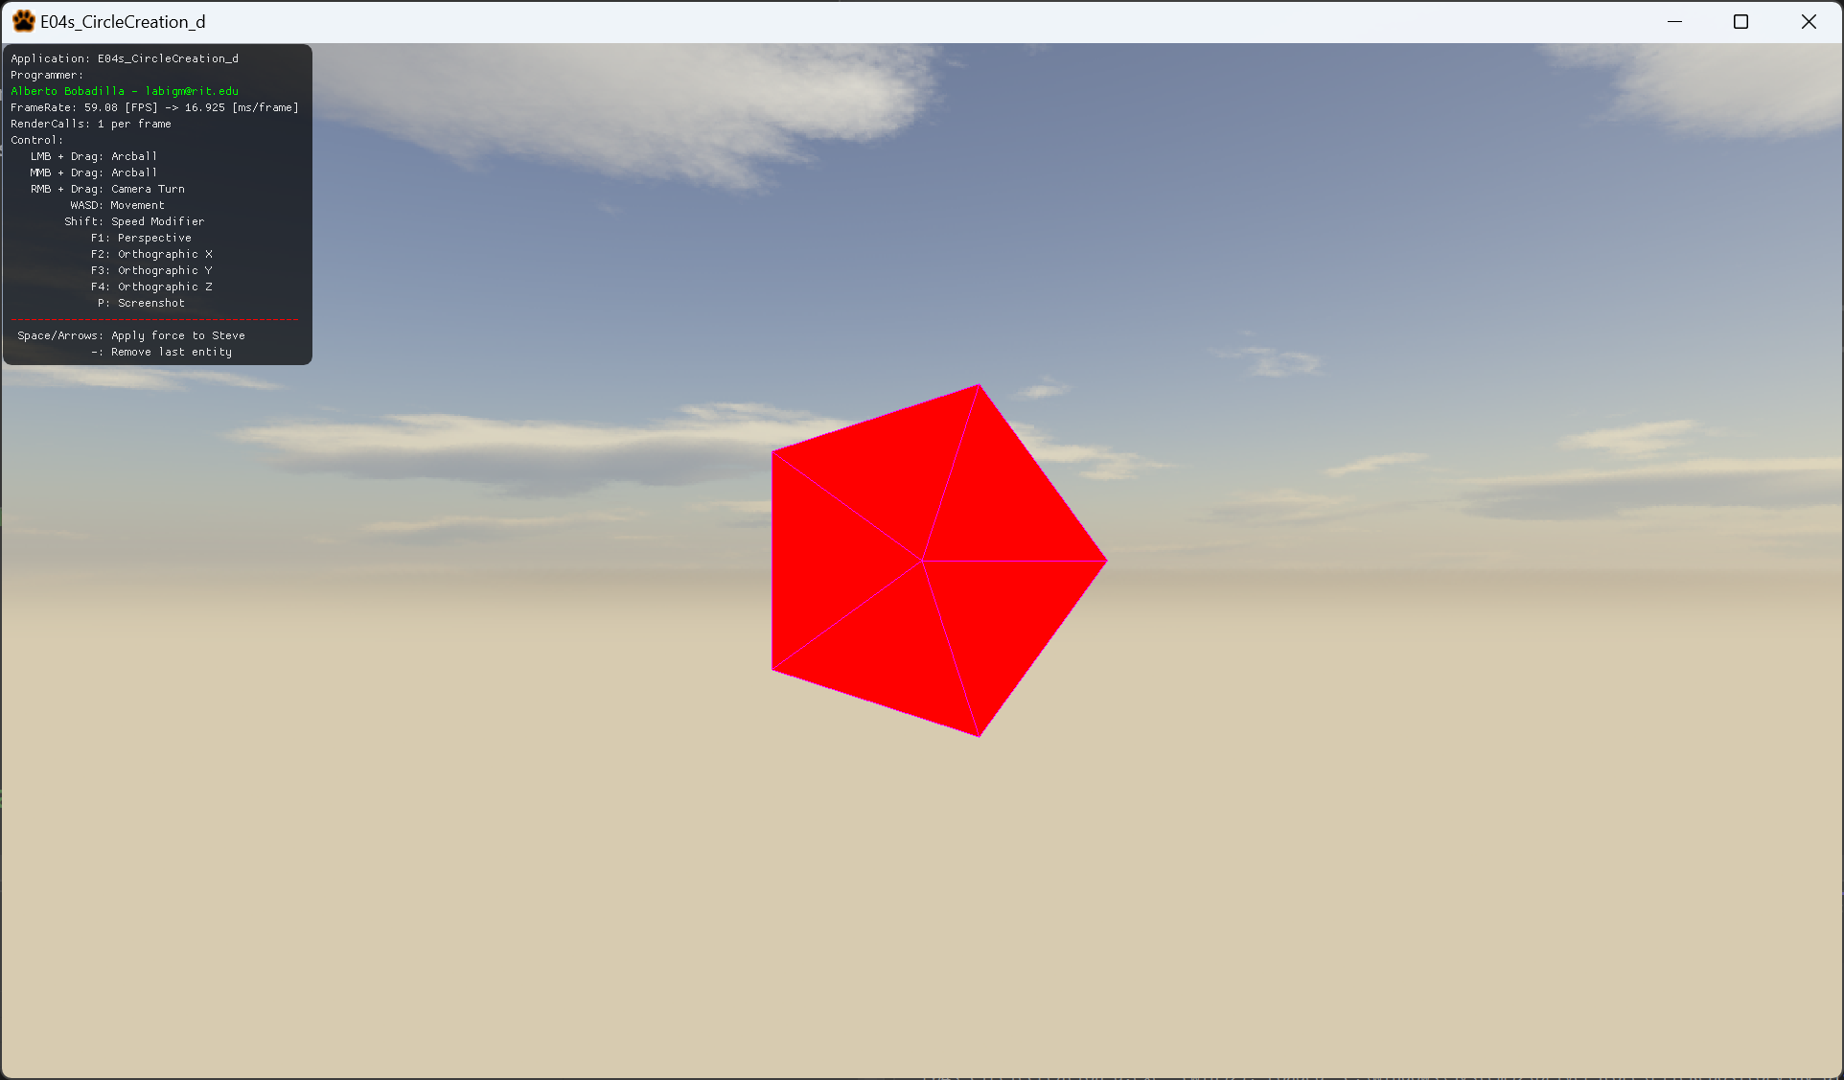

1. For this exercise you will create a dynamic number of triangles that will share an origin point, creating a circle using trigonometry (cosines and sines). It is up to you to ideate the solution for the exercise. Remember you will be using a method that uses this signature:

void GenerateCircle(float a_fRadius, int a_nSubdivisions, vector3 a_v3Color);

The number of subdivisions as you can see is the same number of triangles and the radius is how large is the circle, along with the color of the shape.

1. All your code will be coded in the mesh.cpp file in said function so this is the only file you need to submit to the dropbox in MyCourses, please do not zip this file.

